Type 4: Shooting Star

1. Before a clear uptrend.

2. In the process of rising with a lead and the entity of small candlesticks (not divided into up and down candlesticks.)

3. The length of the upper lead is 2 times the entity, and above, there can be a lower lead, but the requirements are very short.

4. The longer the upper lead, the more obvious the effect.
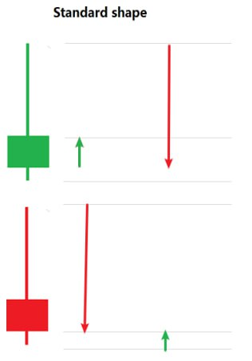
This graphic and what we learned before the hammer line is just a different location, in the process of rising, a sudden rise and then the formation of a longer lead is likely to be the main body pulling high shipping, luring retail investors to grab chips, the stock price quickly high to open the space of the shipment, and then the stock is often the beginning of the weaker.
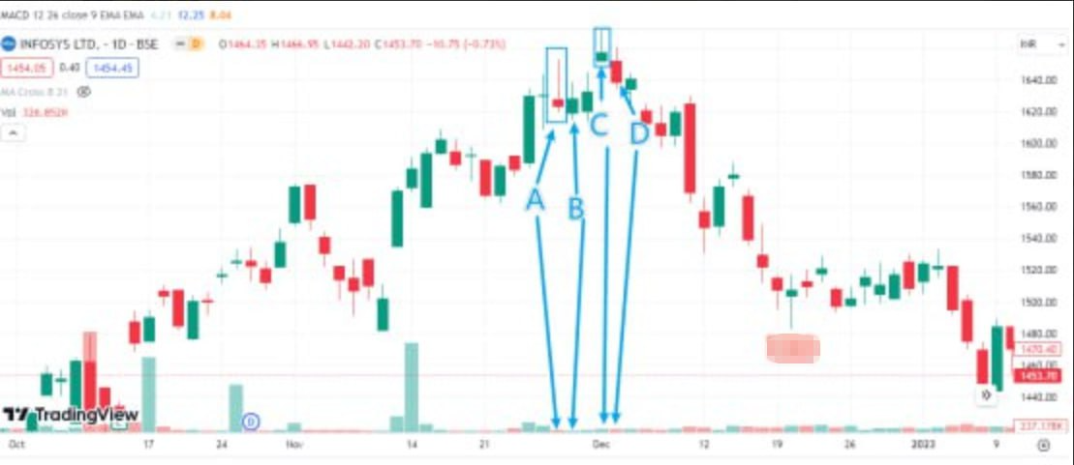
INFY is a more classic effective form and invalid form, we pay attention to observe my marked ABCD position, in the rising stage A at the shooting star form, observe the volume for the performance of the contraction, we observe the B-day to continue to contraction and the price rose back to the previous day's candlestick entity above the previous day's form of judgment is invalid, we continue to look at the C, C once again appeared in a shooting star form, at this time, volume began to enlarge, the next day D volume continued to enlarge, and the price broke the previous candlestick entity, this time the pattern is valid, the market began to decline.

(The tail end of the previous bullish engulfing pattern, the market rebound)
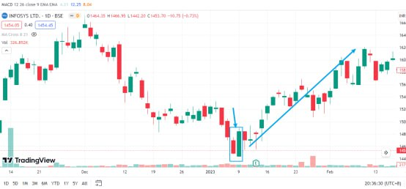
We are in the actual transaction, if the pattern appears but is very non-standard, and difficult to judge, we also use more technical analysis to make the judgment, such as IDBI in the first shooting star of the short signal (at A), but the day's volume performance, not good, we continue to observe. Waiting for the B place again appeared in our study of the multi-needle pattern, and the upper lead line uniformly downward, but the volume performance is still not good, can not judge, as we observe, the C place double average system appeared to be dead, at this time we can judge the volume of the continued low because of the lack of activity in the market, rather than the institution of the washout behavior? So, technical analysis is the accumulation of experience rather than remembering patterns and graphs.
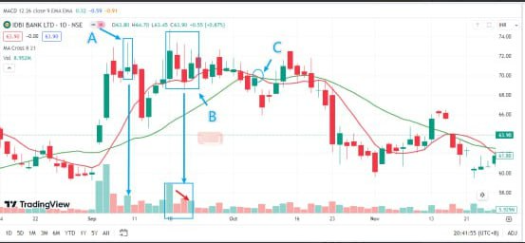
Looking at a typical case TCS, A out of the rising channel, such as the B interval clearly appeared in the situation of the fight between the long and short, and the performance of the majority of the powerless, we should pay special attention to the C and D, the C price fell below the interval, D suddenly pull up prices in the E shooting star form and volume enlargement, this is what behavior? Such a high jump is to induce more retail investors to take over, the main force to flee the typical institutional behavior of the cross, the larger the volume of the day, the more obvious institutional behavior!
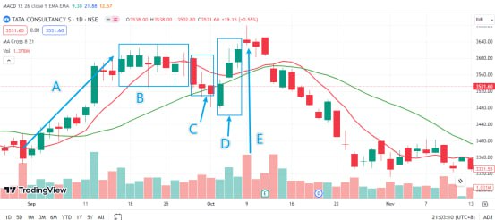
Fifth: Morning Star

1. Generally, a longer solid positive line, the stock price continued strong upward momentum

2. The next day, the stock price jumped high, but the upward momentum significantly weakened, forming a doji pattern (can also be a small entity candlestick does not distinguish between up and down)

3. On the third day, the stock price is slightly lower (flat open can also be) and produces a longer solid negative line, its body part of the obvious downward deep into the first solid positive line, showing that the head form composition, which formed a standard twilight star pattern

4. The pattern does not distinguish between up and down, we look at the standard pattern view, and pay attention to judge the relationship between long and short
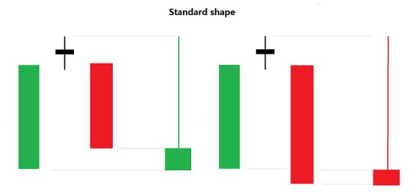
Morning Star, this pattern and the (Bearish) pattern are diametrically opposed buy signal, Morning Star is a sell signal and a combination of three candlesticks, the first candlestick is a big sun, followed by the second candlestick high high open high back down, the third candlestick low open low through the first big sun, the third candlestick of the longer the body, indicating that the power of the short side of the strong, then the market Downside risk increases.
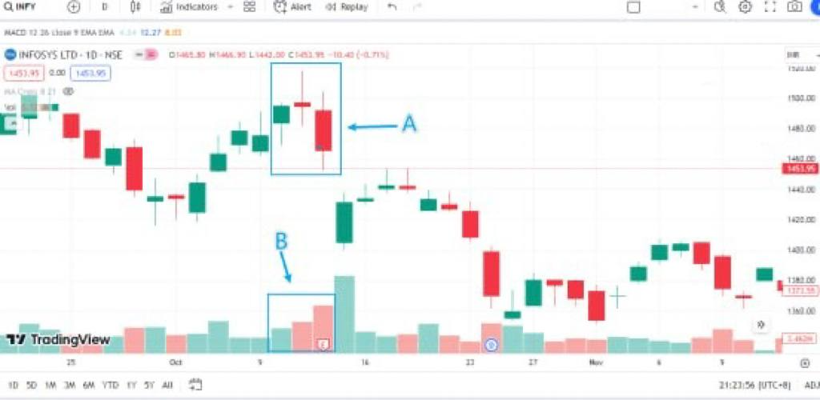
Morning Star, this pattern and the (Bearish) pattern are diametrically opposed buy signal, Morning Star is a sell signal and a combination of three candlesticks, the first candlestick is a big sun, followed by the second candlestick high high open high back down, the third candlestick low open low through the first big sun, the third candlestick of the longer the body, indicating that the power of the short side of the strong, then the market Downside risk increases.

Let's take a look at the standard pattern INFY at A, the first rising candlestick, the second high open closed down and the entity of the small candlestick showing a cross-state, the third day low open low and completely engulfed the first candlestick, volume performance is good. Although there is a violent pull-up in the latter part of the day, it is difficult to recover.
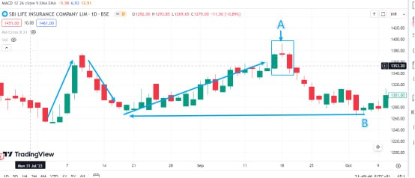
We are trading in the process should also be combined with the overall trend of analysis and judgment, such as SBILIFE, A out of the Morning star pattern, but we observe that the previous rise is not much, and before there was a wave of the pull-up, so in the form of the emergence of the downtrend can not be overly high expectations, the price of the back to the step on the support of the B appeared to fall when the bulls are strong again, we give up on the bearishness of the stock!
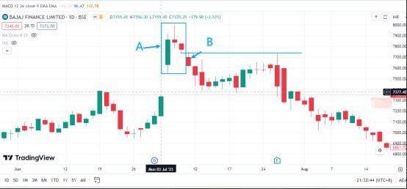
In daily life, in general, it is more difficult to meet the standard form of production, such as in BAJFINANCE in A, the second day of the candlestick for the flat opening, the third candlestick did not penetrate the rising candlestick half, at this time we can continue to observe the performance of the next trading day, the fourth candlestick obviously penetrated the rising candlestick, according to the relationship between the short and the long we can also judge the validity of the signal of the short position!
Sixth type: Guillotine

1. The SMA system is set to MA8 and MA21.

2. The stock price in the process of rising, one day suddenly closed a large negative line, and this large negative line fell through the 8-day, 21-day average.

3. Volume has an obvious performance.
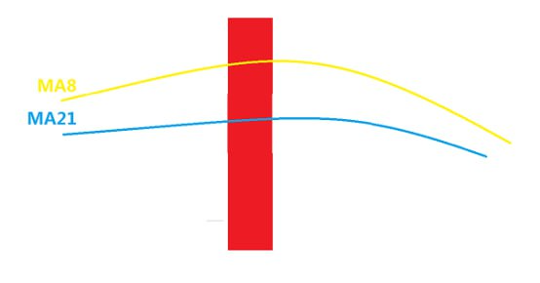
Broken Guillotine pattern, this is the first to give you and indicators combined with the analysis of the averages, the stock price was in the process of rising, one day suddenly closed a large negative line, this large negative line fell through the 8 day, 21-day averages, this way, short-term and then break through upward pressure will be very heavy (the standard is 5.10.30, I've always stressed that do not remember the model, but a deep understanding of the), even if it is a long market generally need to Re-accumulation of power to attack, so the guillotine pattern we generally believe that the stock price in the short term will fall, we look at the chart!
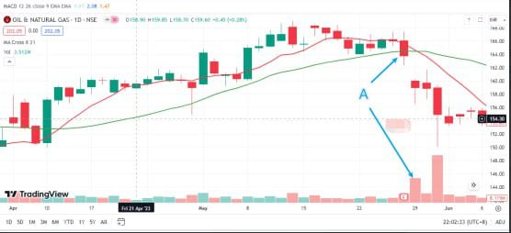
ONGC as an example, the previous rise and then the long performance powerless in 5-26, the day fell sharply below the 8-day and 21-day average, effectively indicating that the day of the short side began to power, followed by a jump in the rapid decline in the market, the price fell straight down to the pre-low near the 31st volume continued to zoom in, and accompanied by a long under the lead indicates that the long side began to return to participate, so we have to be in the actual use of the Concerned about the overall market trend, the formation of a sharp judgement of the power of long and short so that we can form a good trading ecology!
We recently shared six rising combination patterns and six falling combination patterns. We have comprehensive knowledge of candlestick charts, and throughout our explanation, we emphasized that moving averages (MA) and volume are separate technical indicators. However, when combined, they create a stronger analytical tool through multi-indicator resonance. Each individual technical pattern has its limitations, but by integrating multiple indicators, we can significantly improve our accuracy in trading decisions. In our upcoming lesson on volume discipline, I hope you will learn to utilize this complete trading system effectively.

